

Hello, everyone!

Let me talk about data analytics every week – It will be a study for myself and hopefully some useful information for you and the department.

Can you count how many leaves are in the photo above?

You might answer me that I am crazy and yes, you might be correct.

I actually want to talk about DATA not the leaves - measuring data surrounding us is quite similar to counting the leaves in the photo. It is hard to measure the size of data as they are presented in too many different ways and appear in enormous amounts. Data are not only tables anymore – they might be maps, sounds, text and/or images. They are not only static anymore - they are floating, flowing and transforming all the time. What is different between these two might be that the leaves are more beautiful when they are gathering together and the data are more beautiful when they are intelligised.

As the first information to share with you, I would like to introduce TICKETS – what??

I can guess what you think…

I know that we issue, deal with, and close (or try to close) tickets in our daily activities. Now how about letting the tickets tell their own stories instead of actively driving them?

Just sit back and enjoy a cup of coffee ^^

How many tickets do you deal with every day?

What do the tickets mean to you at your daily work?

My seat is just nearby (actually inside of) the support team: I see how they manage a large number of tickets everyday - it is quite impressive and my curiosity about TICKETS has been popping up since I started last December. I found survey data on tickets from SAP CRM, analysed it, and would like to share the story with you.

[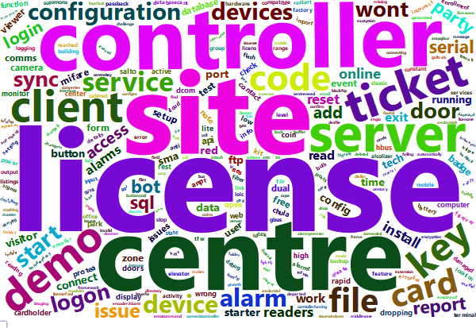](file:///C:\Users\parky\Documents\R\20190504_ticketSurveyAnswers\wordCloud_tickets.html)

Word clouds are a popular visualization tool to represent how often the words appear in a certain context – it emphasizes the strength of their occurrences. The above word cloud is based on 1160 tickets internally and externally issued. From this word cloud, it is easy to find out that LICENSE is the winner of the words in the context of tickets –this word appeared 78 times. SITE, CENTRE and CONTROLLER are quite eye-catching words too – they are appeared 63, 57 and 48 times each.

Did you find any interesting words rather than the highest ranking words?

They are mostly predictable to my eyes – you might have a different view, though.

Interestingly, the fifth word is GALLAGHER with 40: it is not shown in the image above because of the limited space for the visualization: you can see the whole image from the hyperlinked attachment if you wish to satisfy your curiosity – it wouldn’t kill the cat!

If you were aroused to question how our customers feel after the service they requested was completed, you could go further – You would be happy.

Enjoy the last bit of information ☺

